Window Lifter
SW Component < Window Lifter >

History
Issue status  (Index) | Maturity/Date  (draft/invalid/valid)  (dd-mmm-yyyy) | Author  Department | Check/Release  Department | Description
1.0 | Draft  04-0ct-09 | Miguel Garcia | Miguel Garcia | Creation of the document
2.0 | Draft  Oct. 25, 2017 | Manuel Hernández | Manuel Hernández/Guillermo Hernández | Insertion of information on fields: Definitions and abbreviations, Realization constraints and targets, SW Conceptual design, Function description and dynamic behavior.
3.0 | Valid  Oct. 25, 2017 | Manuel Hernández | Manuel Hernández/Guillermo Hernández | Modification (actualization) of flux diagram with the overview of the Window lifter process. In section “SW Conceptual design”
4.0 | Valid  Oct. 25, 2017 | Guillermo Hernández | Manuel Hernández/Guillermo Hernández | Detailed descriptive table with static and dynamic behaviors. In section “Function Description and dynamic behavior”.
5.0 | Draft  Oct. 25, 2017 | Manuel Hernández | Manuel Hernández/Guillermo Hernández | Section 5. First Version of Functional Decomposition diagram showing the functions created and used, and the relationship between them.
6.0 | Draft  Oct. 25, 2017 | Guillermo  Hernández | Manuel Hernández/Guillermo Hernández | Section 2. Definitions and abbreviations updated, new functions added.  Section 2. References added (Document names and internet link)
7.0 | Draft  Oct. 25, 2017 | Guillermo Hernández | Manuel Hernández/Guillermo Hernández | Section 5.2. Functions description and dynamic behavior. First version of tables with descriptions. No flux diagrams included yet.
8-0 | Draft  Oct. 26, 2017 | Manuel Hernández | Manuel Hernández/Guillermo Hernández | Section 5.1 Functional decomposition Update. First Version of “APP Layer – Block Definition Diagram” added.
9.0 | Draft  Oct. 29, 2017 | Manuel Hernández | Manuel Hernández/Guillermo Hernández | Section 5.2 .Functions description and dynamic behavior. Tables about EnableTimer500ms (void) were deleted, because a dedicated 500 ms validation was not necessary.
10.0 | Draft  Oct. 29, 2017 | Manuel Hernández | Manuel Hernández/Guillermo Hernández | Section 5.2 .Functions description and dynamic behavior. All diagrams related to the dynamic behavior of the function are included after each function.
11.0 | Draft  Oct. 29, 2017 | Manuel Hernández | Manuel Hernández/Guillermo Hernández | Section 2. Definitions and abbreviations. Deleted unused conceptual definitions from the table.  .Section 3. Realization constraints and targets. Deleted previous table, constraints and targets are correctly defined.  All sections. Foot images.
12.0 | Draft  Nov. 02, 2017 | Manuel Hernández | Manuel Hernández/Guillermo Hernández | Section 2.1. Updated table with proposed CONCEPTUAL definitions for variables, and their respective DSD IDs and STR IDs.
13.0 | Draft  Nov. 02, 2017 | Manuel Hernández | Manuel Hernández/Guillermo Hernández | Section 5 Updated. All table numbers updated.
14 | Draft  Nov. 02, 2017 | Manuel Hernández | Manuel Hernández/Guillermo Hernández | Section 4. Block diagrams of software conceptual design.
15 | Draft  Nov. 02, 2017 | Manuel Hernández | Manuel Hernández/Guillermo Hernández | Section 5.1. Update on static function tree. Deleted previous diagram, uploaded a new “Top, Down” diagram.
16 | Draft  Nov. 03, 2017 | Manuel Hernández | Manuel Hernández/Guillermo Hernández | Section 5.2 update. Corrected Flowcharts of created functions.
17 | Draft  Nov. 03, 2017 | Manuel Hernández | Manuel Hernández/Guillermo Hernández | Section 5.2 update. Deleted unnecessary fields on tables.
18 | Draft  Nov. 05, 2017 | Manuel Hernández | Manuel Hernández/Guillermo Hernández | Section 2.1 Definitions. Update of Matrix SWS IDs.
19 | Draft  Nov. 05, 2017 | Guillermo Hernández | Manuel Hernández/Guillermo Hernández | Section 5.2 Function description and dynamic behavior. Update the descriptions of the functions
20 | Draft  Nov. 05, 2017 | Manuel Hernández | Manuel Hernández/Guillermo Hernández | Section 5.2 Function description and dynamic behavior. All flowcharts included with every function.
21 | Draft  Nov. 26, 2017 | Manuel Hernández | Manuel Hernández/Guillermo Hernández | Section 1. Purpose. Updated to FSM and Scheduler concepts.
22 | Draft  Nov. 26, 2017 | Manuel Hernández | Manuel Hernández/Guillermo Hernández | Section 3. Realization constraints and targets. Minor update according to new requirements.
23 | Draft  Nov. 26, 2017 | Manuel Hernández | Manuel Hernández/Guillermo Hernández | Section 4. SW Conceptual design. Finite State Machine diagram of the Tasks.c file included.
24 | Draft  Nov. 26, 2017 | Manuel Hernández | Manuel Hernández/Guillermo Hernández | Section 5.2 Update .Function (Finite State Machine) Description and Dynamic Behavior tables added.
25 | Draft  Nov. 27, 2017 | Manuel Hernández | Manuel Hernández/Guillermo Hernández | Section 5.2: Function (Finite State Machine) Description and Dynamic Behavior diagrams added.
26 | Draft  Nov. 27, 2017 | Manuel Hernández | Manuel Hernández/Guillermo Hernández | Section 4. SW Conceptual design. Finite State Machine diagram updated.
27 | Draft  Nov. 27, 2017 | Manuel Hernández | Manuel Hernández/Guillermo Hernández | Section 5.2. Small corrections on Diagrams.
28 | Valid  Nov. 27, 2017 | Manuel Hernández | Manuel Hernández/Guillermo Hernández | Previous to Final minor modifications (image footers)
29 | Valid  Nov. 28, 2017 | Manuel Hernández | Manuel Hernández/Guillermo Hernández | Section 5. Function static tree included.
30 | Valid  Dec. 1st, 2017 | Manuel Hernández | Manuel Hernández/Guillermo Hernández | Section 4. Corrected FSM.

Table of Contents
1 Purpose 4
2 Definitions and abbreviations 4
2.1 Definitions 4
2.2 Abbreviations 8
2.3 References 8
3 Realization constraints and targets 8
3.1 About the objectives: 8
3.2 About the IDE: 9
3.3 About the development kit: 9
3.4 About the electronic components: 9
4 SW Conceptual design 9
5 SW Component internal breakdown 13
5.1 Functional Decomposition 13
5.2 Function (Finite State Machine) Description and Dynamic Behavior. 14
5.2.1 DSD_23 - case 1, equivalent to “State 1: Nothing” 14
5.2.2 DSD_24 – Case 2, equivalent to “State 2: Debounce” 15
5.2.3 DSD_25 – Case 3, equivalent to “State 3: Mode selection” 16
5.2.4 DSD_26 – case 4, equivalent to “State 4: Automatic” 17
5.2.5 DSD_27 – case 5, equivalent to “State 5: Manual” 18
5.2.6 DSD_28 – case 6, equivalent to “State 6: Antipinch” 19
5.2.7 DSD_29 – case7, equivalent to “State 7: Wait 5 seconds” 20

Purpose
This document aims to present in a detailed way the software description and all of the components based on the requirements, to fulfill the Window lifter module as specified in “STR_WindowLifterModule.docx”. Then, the module will be implemented with the aid of a previously made Scheduler software, and re-designed with the Finite State Machine concept.

Definitions and abbreviations

Definitions
Note: In this table only functional requirements are stated and are given a DSD ID.
Requirements Traceability ID | Matrix STR Description | Proposed Variable and Function Definitions that contribute to solve the Requirement. | Design Description of the definition. | Design Traceability ID
SWS_00 | The software module "Window lifter" shall control window movement (up/down behavior, anti-pinch functionality, one touch function) | Main.c | Software file that contains all the necessary routines that solve the requirements. | DSD_00
SWS_05 | The signal of the UP switch shall be detected. | DownButton | Variable to store the signal of the “Down” pushbutton | DSD_01
SWS_06 | The signal of the DOWN Switch shall be detected | UpButton | Variable to store the signal of the “Up” pushbutton | DSD_02
SWS_07 | The signal of the Anti-Pinch Switch shall be detected | PinchButton | Variable to store the signal of the “Pinch” pushbutton | DSD_03
SWS_08 | The software shall be able to use 10 digital outputs (for the LED bar) | LEDBarPortConfig | Function to configure the 10 outputs for the LED bar. | DSD_04
SWS_11 | Time between transitions shall be 400 ms | Wait400Milis | Function that configures the timer to work with a 400 ms. Counting | DSD_05
SWS_13 | To indicate the UP mode, a blue LED shall be turned ON | ActivateUpSequence | Bit flag to indicate that the Up animation of the LEDs is active (in course) | DSD_06
SWS_14 | To indicate the DOWN mode, a green LED shall be turned ON | ActivateDownSequence | Bit flag to indicate that the Down animation of the LEDs is active (in course) | DSD_07
SWS_15 | A validation of a pressed switch shall be done | ValidPressFlag | Bit flag to indicate a valid button press. | DSD_08
SWS_16 | The switch (UP,DOWN & Anti-Pinch-Switch) shall be pressed at least 10 ms to be validated as a valid press | Wait10Milis. | Function that configures the timer to work with a 10 ms counting | DSD_09
SWS_17 | Detect an invalid switch press (UP,DOWN, and Anti-Pinch) | FailDownPressFlag | Bit flag to indicate the activation of the Fail Down Press event. | DSD_10
SWS_17 | Detect an invalid switch press (UP,DOWN, and Anti-Pinch) | FailUpPressFlag | Bit flag to indicate the activation of the Fail Up Press event. | DSD_11
SWS_17 | Detect an invalid switch press (UP,DOWN, and Anti-Pinch) | FailPinchPressFlag | Bit flag to indicate if the Pinch Button Press has failed | DSD_12
SWS_18 | Detect an invalid switch press combination (UP,DOWN and Anti-Pinch) | InvalidCombinationFlag | Bit flag to indicate an invalid combination of buttons being pressed. | DSD_13
SWS_19 | "One Touch Mode " shall be available. |  |  | DSD_14
SWS_20 | If the DOWN-switch has a validated pressing for less than 500 ms, the window shall move DOWN until the window gets totally open (One Touch Mode) | OneTouchDownFlag | Bit flag to indicate the activation of the “One Touch Down” functionality | DSD_15
SWS_21 | If the DOWN-switch has a validated pressing for more than 500 ms, the window shall move DOWN while the DOWN switch is kept press | ManualDownFlag | Bit flag to indicate the activation of the manual Down movement. | DSD_16
SWS_22 | If the UP-switch has a validated pressing for less than 500ms, the window shall move UP until the window get totally closed (One Touch Mode) | OneTouchUpFlag | Bit flag to indicate the activation of the “One Touch Up” functionality | DSD_17
SWS_23 | If the UP-switch has a validated pressing for more than 500ms, the window shall move UP while the UP switch is kept pressed | ManualUpFlag | Bit flag to indicate the activation of the manual UP movement. | DSD_18
SWS_24 | Anti-Pinch mode must be available | This requirement breaks down into four: from LLR_14 to LLR_17 | This requirement breaks down into four: from LLR_14 to LLR_17 | DSD_19
SWS_26 | Pinch signal shall be read and validated only when the "UP" mode is active. | PinchFlag | Bit flag to indicate a Pinch Event | DSD_20
SWS_27 | If the Anti-Pinch mode is validated, the window shall stop, and enter to the "DOWN" mode until the window get totally open | StopWindowMovement | Function that holds the level (number of LEDs turned ON). | DSD_21
SWS_28 | If the Anti-Pinch mode was validated and the window is totally open, the module shall ignore all the button press for the next 5 seconds | WaitFiveSec | Function that configures the timer to work with a 5 seconds counting | DSD_22
SWS_29 | After the 5 seconds of ignoring all the button press, recognize all the button press | It doesn’t need a specific function. | It doesn’t need a specific function. | It doesn’t need a specific ID because SW returns to DSD_08.
Table 1. Variables and functions definitions.

Abbreviations

SW = “Software”
HW = “Hardware”

References

N° | Document name | Reference
1  2  3  4  5 | S32K- Reference Manual  S32K-User Guide  S32K- CookBook  S32K-DataSheet  S32K-QuickStartGuide (QSG) | https://www.nxp.com/products/microcontrollers-and-processors/arm-based-processors-and-mcus/s32-automotive-platform/s32k144-evaluation-board:S32K144EVB?tab=Documentation_Tab

Realization constraints and targets

The development team shall deliver only the embedded software and physical components that satisfy the requirements established and revised in the “STR_WindowLifterModule.docx” and “Traceability_Matrix.xls” documents.

In addition, the generated software of the Window Lifter Module shall be adjusted to work according to a designed Finite State Machine and shall be also implemented with the configured Scheduler that was given to the group.

About the objectives:
To simulate the movement of a car’s window, with the functionalities:
- Validate a button press if the button is pressed for more than 10 msec.
- One touch mode (keep button pressed for less than 500 msec)
- Manual mode (keep button pressed for more than 500 msec).
- Anti-pinch (only available when the UP sequence in One Touch Mode is active)
- Adjust the Window Lifter Module software so it can be implemented with a Finite State Machine and the Scheduler software given to the group.

About the IDE:
The software that will be used is the “S32 Design Studio for ARM v2.0” provided by NXT.

About the development kit:
The board in which the embedded software will be implemented is the S32K144EVB: Evaluation Board, also provided by NXT.

About the electronic components:
Component | Description | Quantity
10 LED bar | Red color | 1
330 ohm resistor (proposed) | To lower the voltage of the S32K144 EVB that will feed the LEDs bar. | 10
0.1 uF capacitor (optional) | Capacitor that will filter the noise caused by the bounce of the “pinch” pushbutton.. | 1
External pushbutton (proposed) | Pushbutton dedicated for the “Pinch” signal. | 1
10 kOhm resistor (proposed) | Pullup resistor to work with the Anti pinch pushbutton. | 1
Jumper male-to-male cable (proposed) | Jumper that will allow the signal to turn on the LEDs from the NXT development PCB to the 10 LED bar. One more jumpers will be used also to communicate the NXP board with the “Pinch” pushbutton. Two more will provide +5V DC and GND to the protoboard in which the circuit will be implemented. | 13
Proto-board (proposed) | In the early stages of the development of the Window Lifter module, this will serve to implement the external circuitry. | 1
Table 2. Electronic components for the Window lifter module.

SW Conceptual design
Note: To have a clear view of the diagram, please zoom until desired clarity is reached, given that the image is a *.png file.

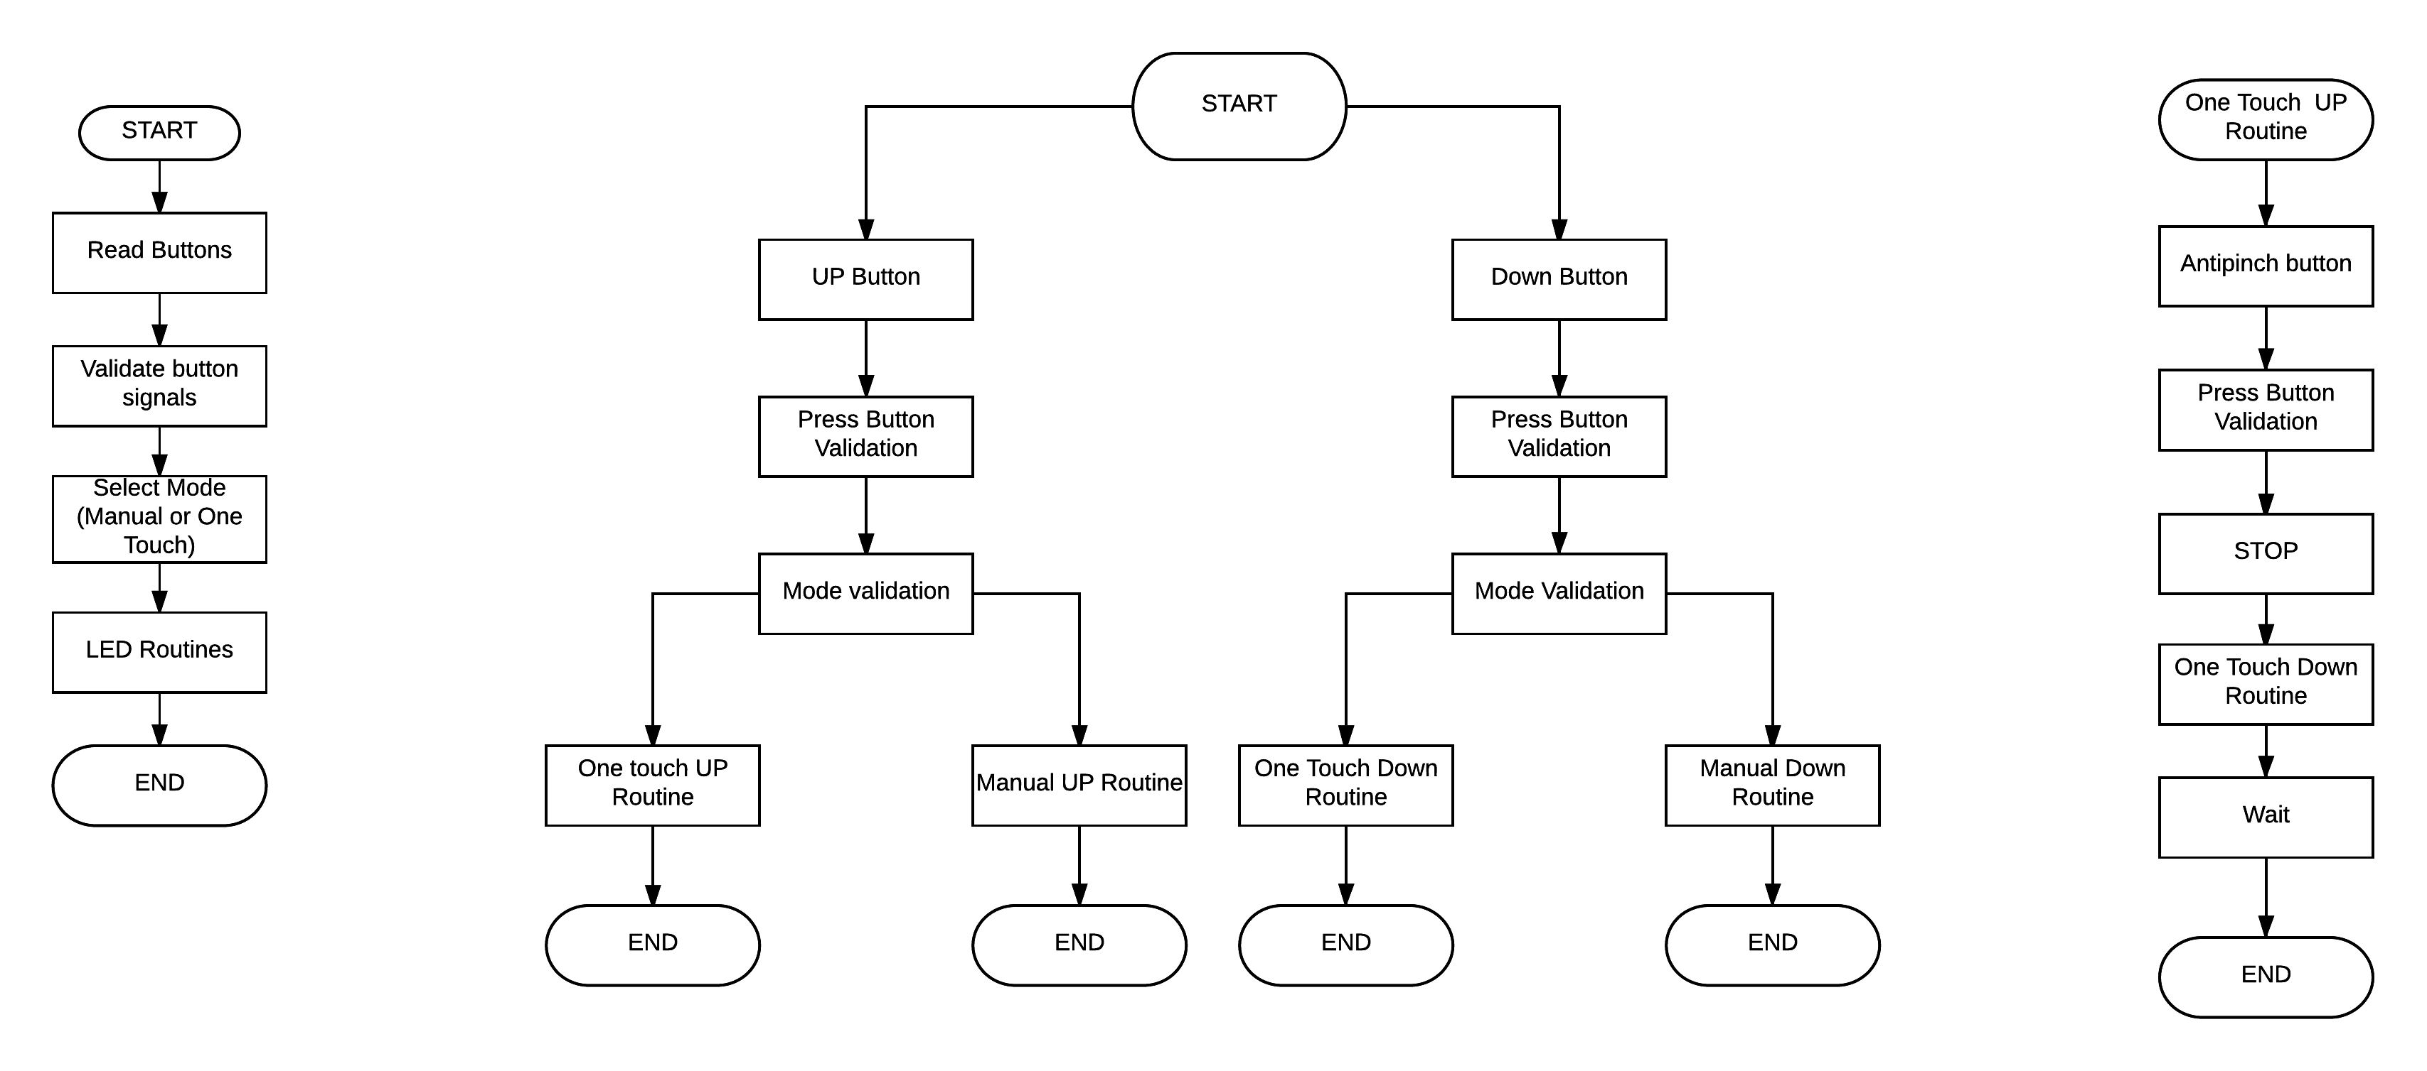
Image 1. Conceptual functional design.

Image 2. Conceptual functional design - breakdown.
Image 3. One touch UP routine breakdown.

Important note: Please zoom the page to get a clearer view of the FSM diagram (.png format). The colors were used without any convention, just to avoid confusion of transitions between different states.

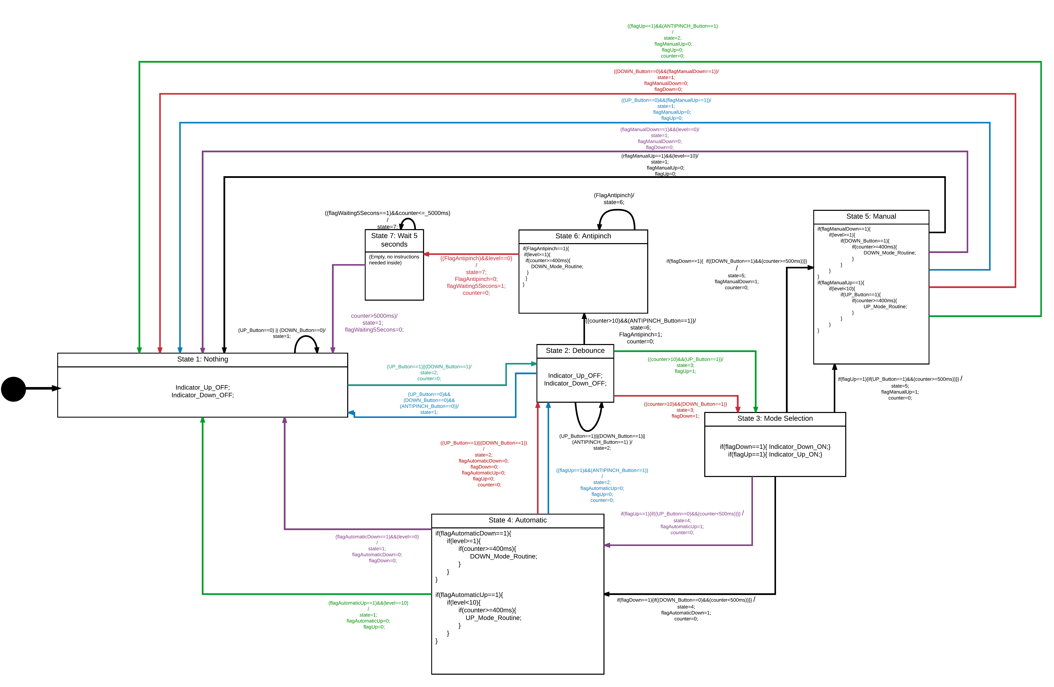
Image 4. Finite State Machine of the Window Lifter Tasks Code.

SW Component internal breakdown

Functional Decomposition
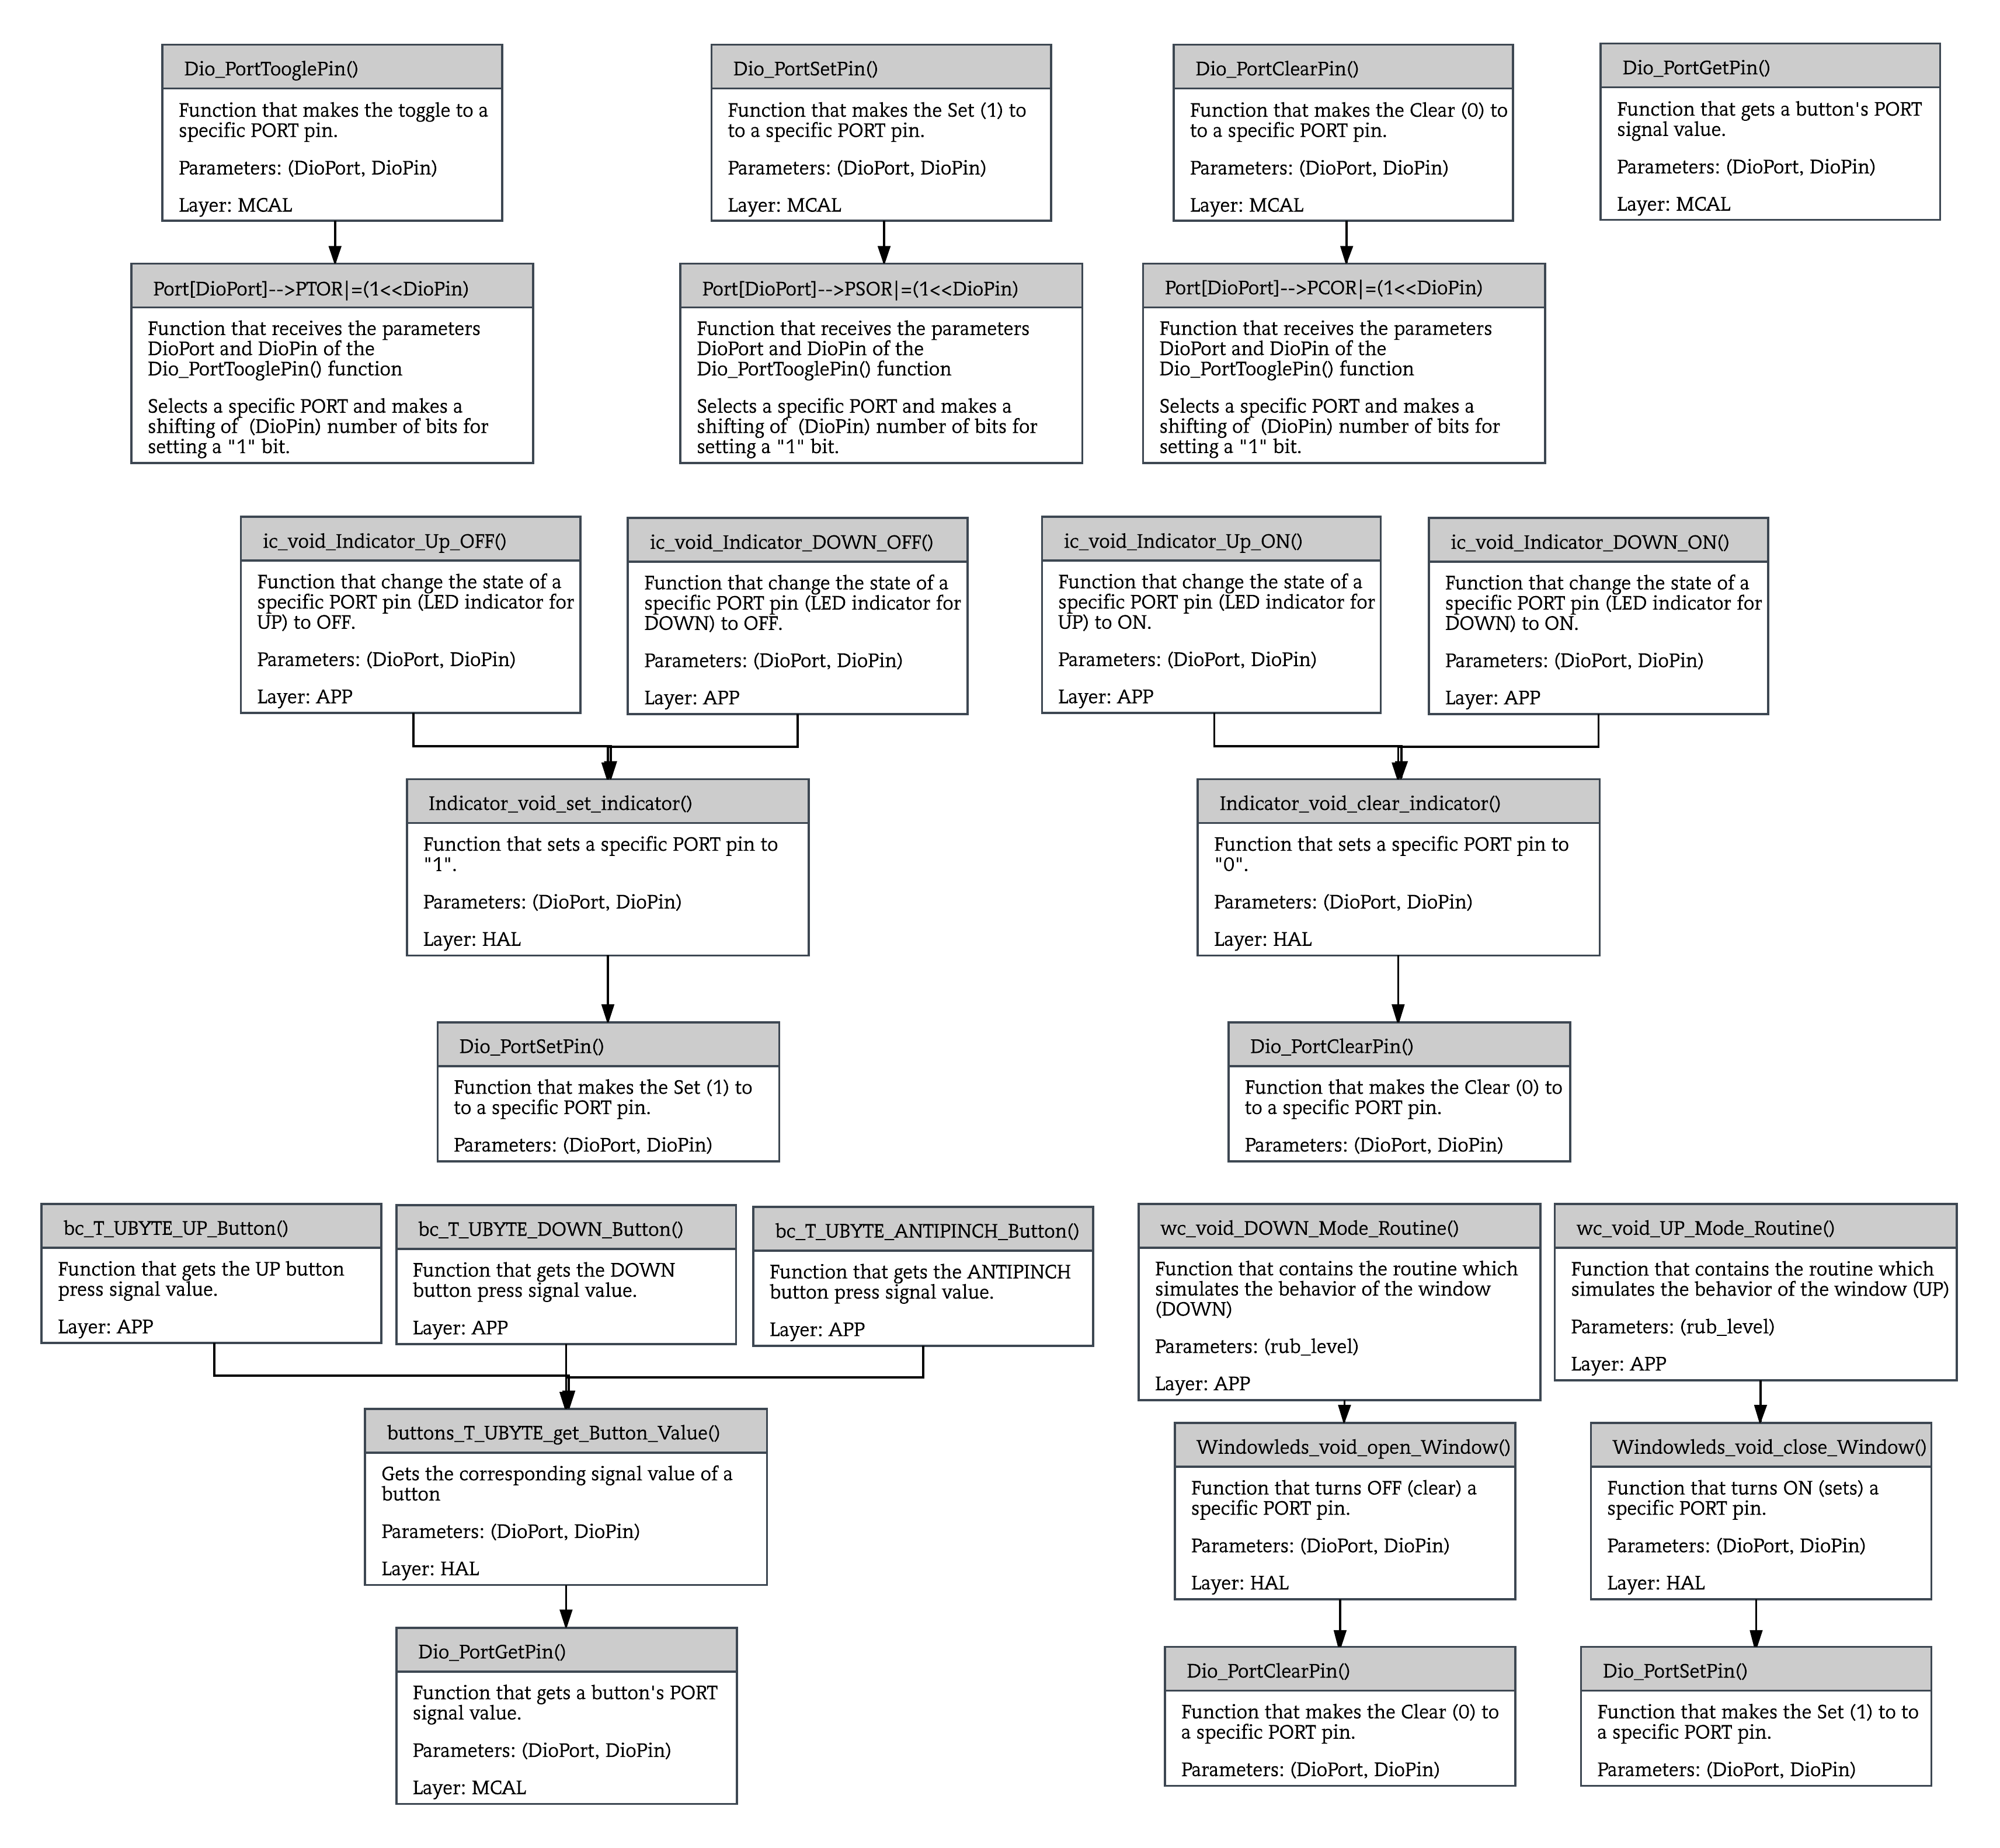
Image 5. Static tree of functions.

Function (Finite State Machine) Description and Dynamic Behavior.

DSD_23 - case 1, equivalent to “State 1: Nothing”
Description | It contains the instructions needed to indicate that there is an absence of button presses. Movement indicators are OFF.
Parameter 1  <input| output| inout> | Parameter “state” is a static unsigned char type of variable
Return Value | This function has no return value, because it uses the parameter “state” only to evaluate it.
Precondition | State=Default;  State=1;  State=7;  State=4;  State=2;
Post condition | Depending on the transitions (arrows of the Finite State Machine diagram) pre-conditions, the possibilities of the State post-condition are as follows:  State=1;  State=2;
Error Conditions | The error conditions were analyzed and a “default” state was included to solve it

Table 3. Case 1, equivalent to “State 1: Nothing”

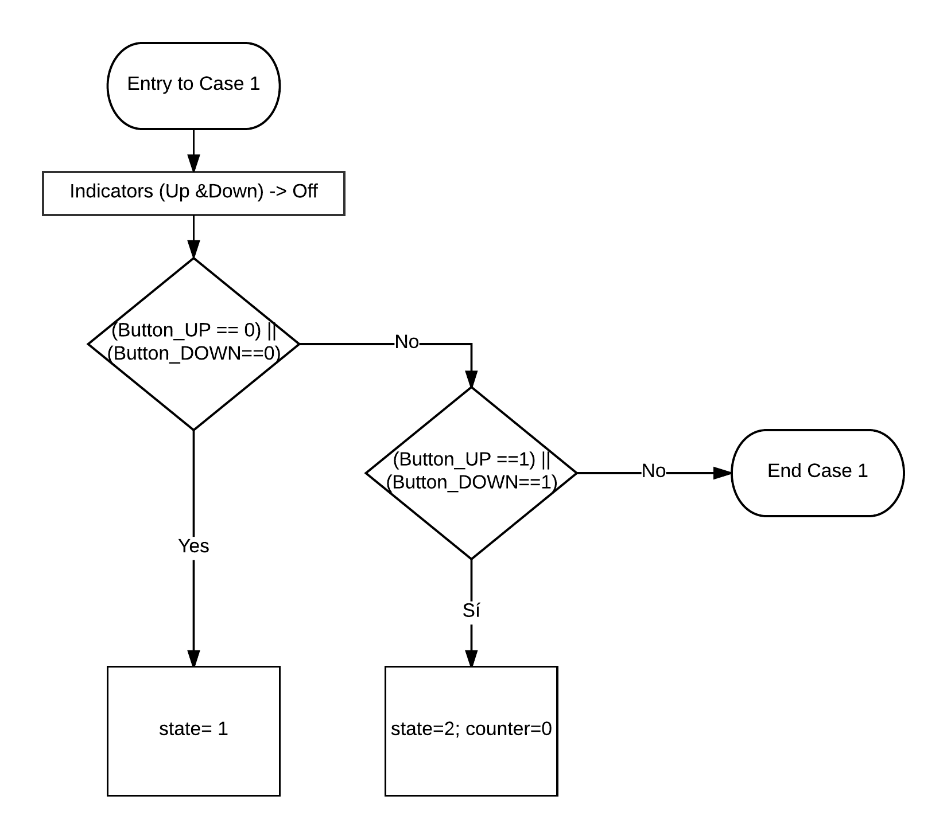
Image 6. “State 1: Nothing” dynamic behavior.

DSD_24 – Case 2, equivalent to “State 2: Debounce”
Description | Movement indicators are OFF.
Parameter 1  <input| output| inout> | Parameter “state” is a static unsigned char type of variable
Return Value | This function has no return value, because it uses the parameter “state” only to evaluate it.
Precondition | State=Default;  State=1;  State=4;  State=2;
Post condition | Depending on the transitions (arrows of the Finite State Machine diagram) pre-conditions, the possibilities of the State post-condition are as follows:  State=1;  State=2;  State=3;  State=6;
Error Conditions | The error conditions were analyzed and a “default” state was included to solve it

Table 4. case 2, equivalent to “State 2: Debounce”

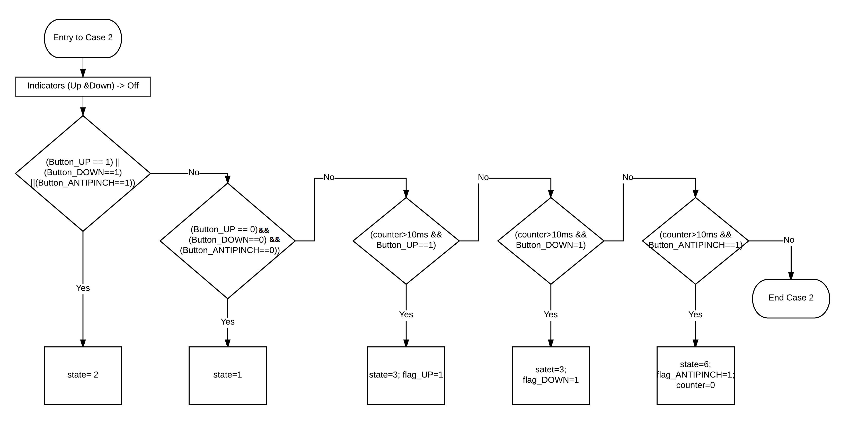
Image 7. “State 2: Debounce” dynamic behavior.

DSD_25 – Case 3, equivalent to “State 3: Mode selection”
Description | The mode in which the module shall start to operate (UP or DOWN) is selected with the corresponding button presses, and the indicators shall be turned ON.
Parameter 1  <input| output| inout> | Parameter “state” is a static unsigned char type of variable
Return Value | This function has no return value, because it uses the parameter “state” only to evaluate it.
Precondition | State=Default;  State=2;
Post condition | Depending on the transitions (arrows of the Finite State Machine diagram) pre-conditions, the possibilities of the State post-condition are as follows:  State=4;  State=5;
Error Conditions | The error conditions were analyzed and a “default” state was included to solve it

Table 5. case 3, equivalent to “State 3: Mode selection”

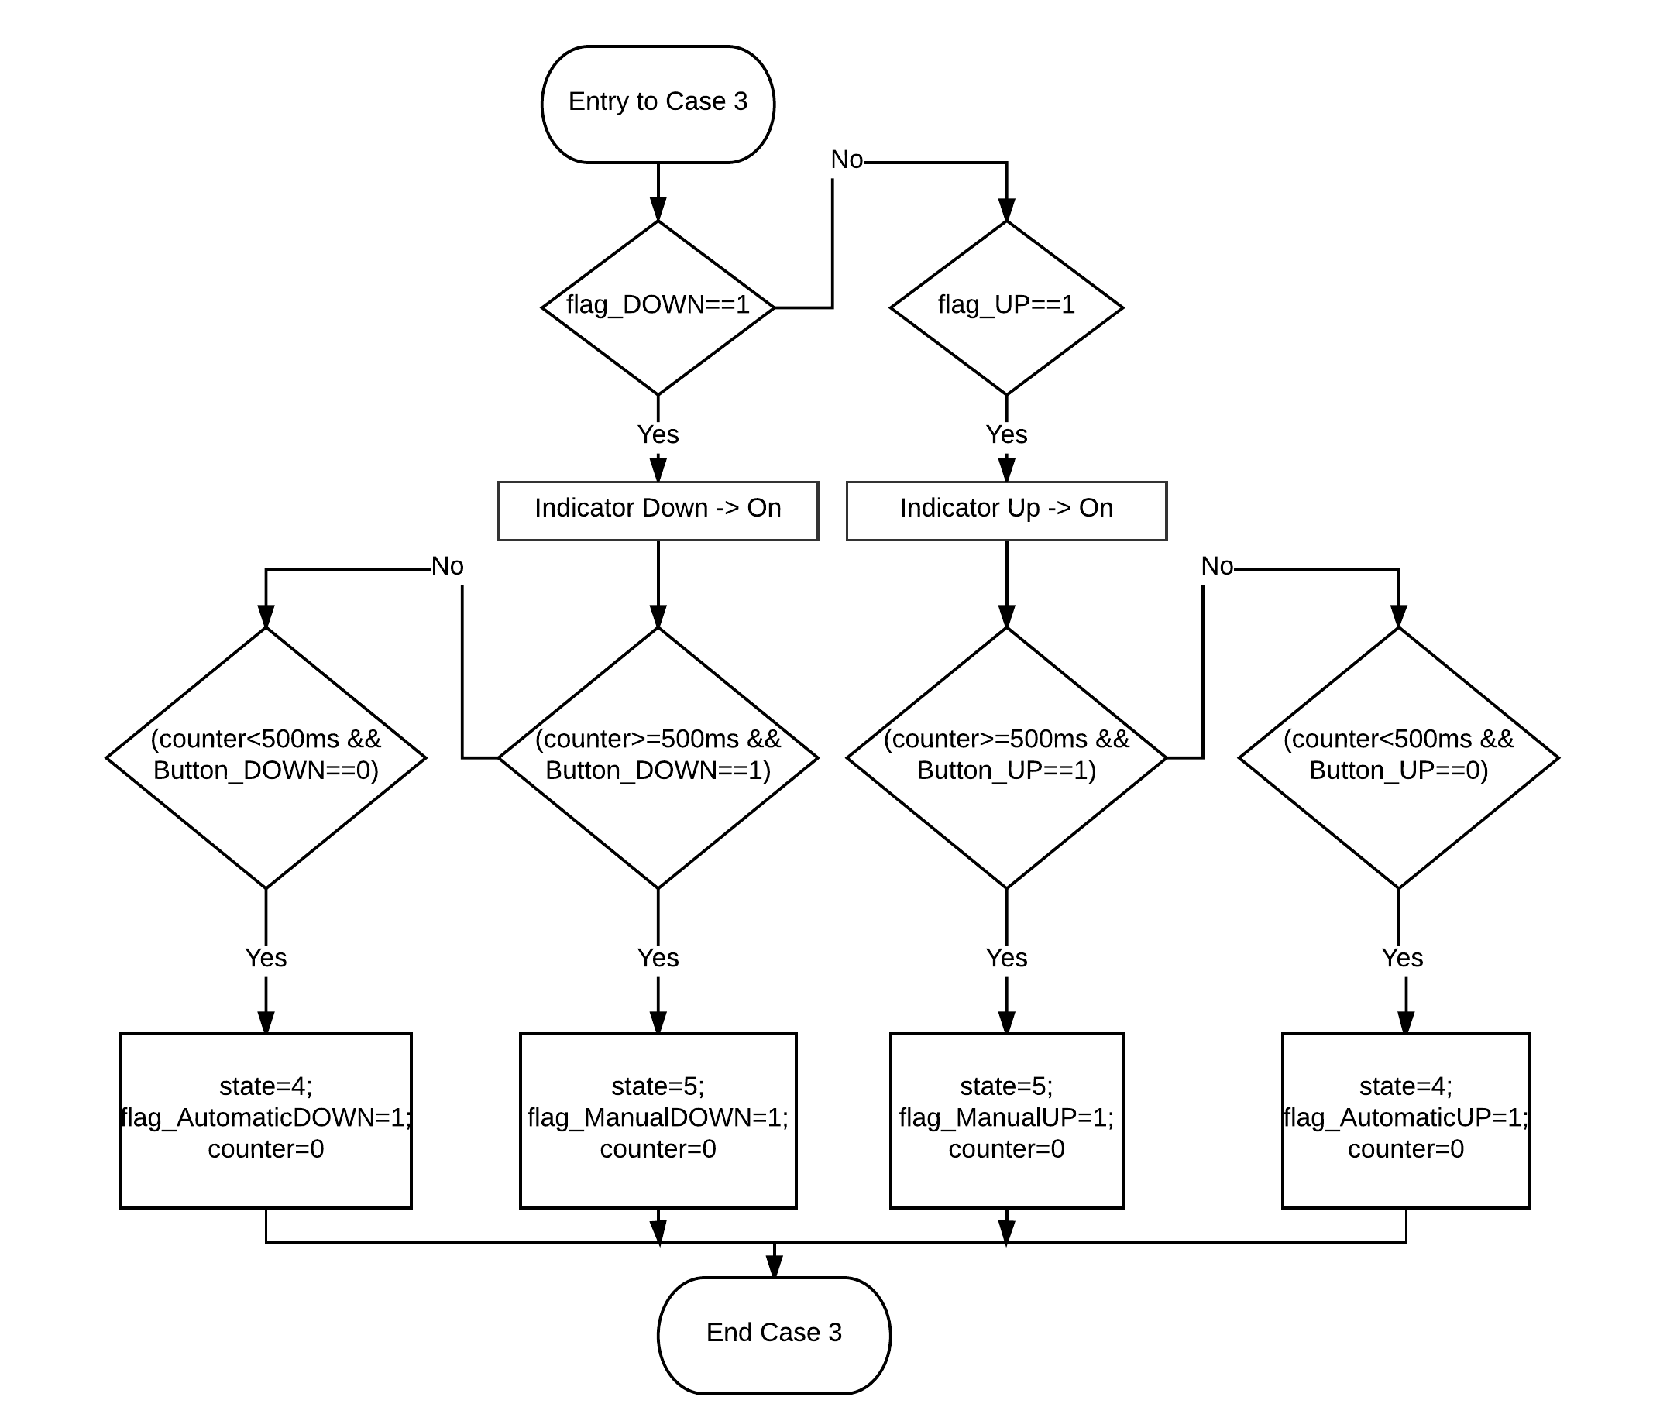
Image 8. “State 3: Mode selection” dynamic behavior.

DSD_26 – case 4, equivalent to “State 4: Automatic”

Description | There shall take place two validations, one for the Automatic Down Movement and another for the Automatic Up movement.
Parameter 1  <input| output| inout> | Parameter “state” is a static unsigned char type of variable
Return Value | This function has no return value, because it uses the parameter “state” only to evaluate it.
Precondition | State=Default;  State=2;  State=3;
Post condition | Depending on the transitions (arrows of the Finite State Machine diagram) pre-conditions, the possibilities of the State post-condition are as follows:  State=1;  State=2;
Error Conditions | The error conditions were analyzed and a “default” state was included to solve it

Table 6. case 4, equivalent to “State 4: Automatic”

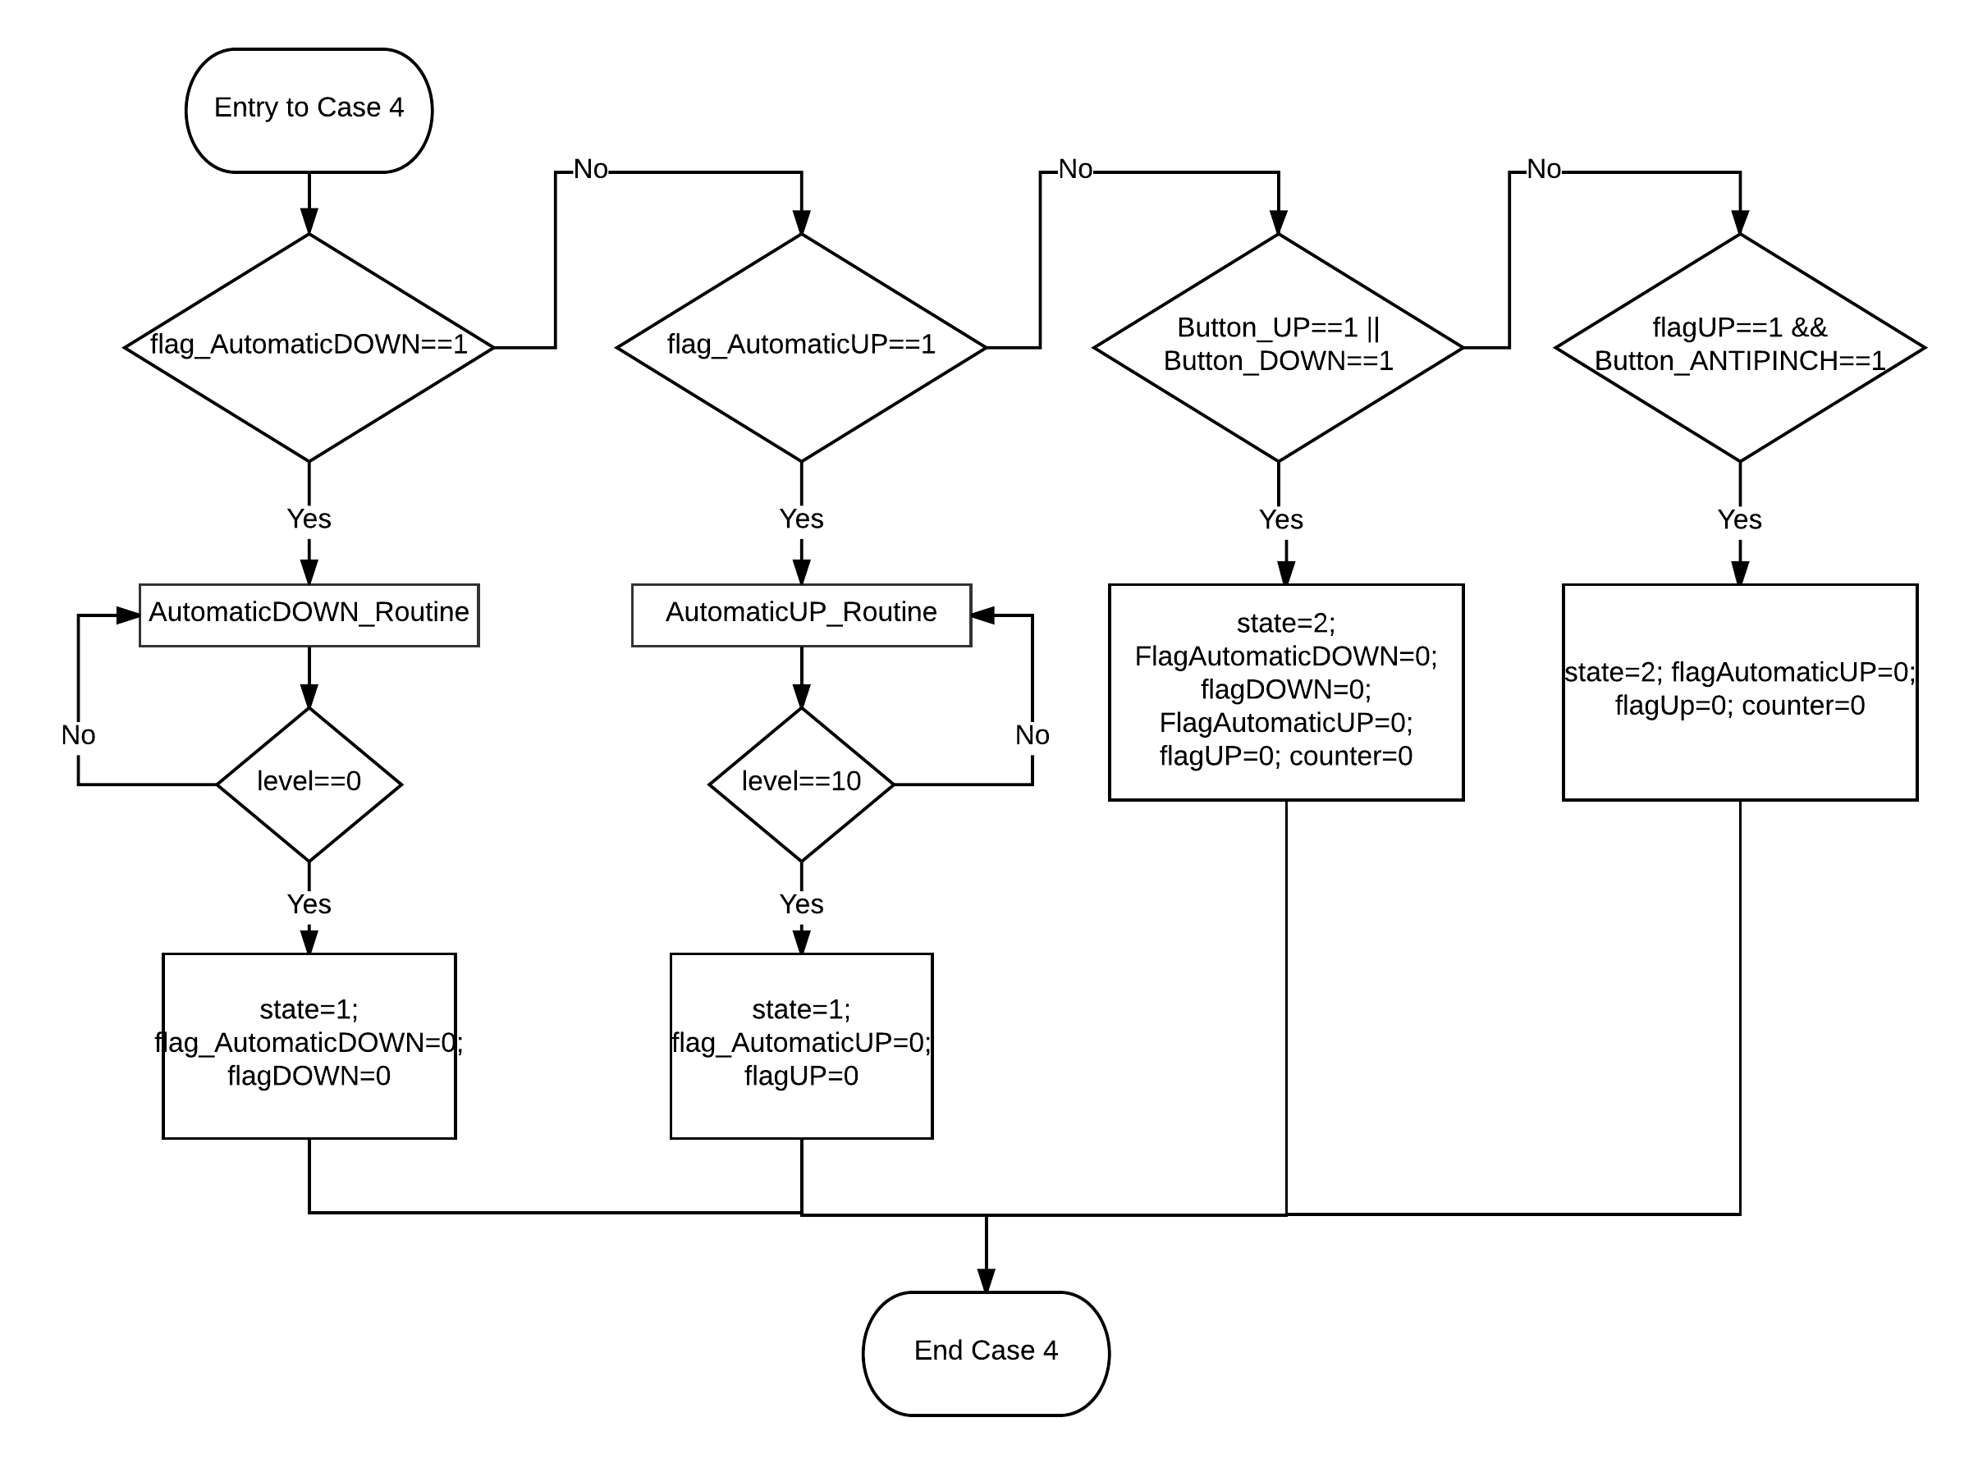
Image 9. “State 4: Automatic” dynamic behavior.

DSD_27 – case 5, equivalent to “State 5: Manual”

Description | There shall take place two validations, one for the Manual Down Movement and another for the Manual Up movement.
Parameter 1  <input| output| inout> | Parameter “state” is a static unsigned char type of variable
Return Value | This function has no return value, because it uses the parameter “state” only to evaluate it.
Precondition | State=Default;  State=3;
Post condition | Depending on the transitions (arrows of the Finite State Machine diagram) pre-conditions, the possibilities of the State post-condition are as follows:  State=1;  State=2;
Error Conditions | The error conditions were analyzed and a “default” state was included to solve it

Table 7. case 5, equivalent to “State 5: Manual”

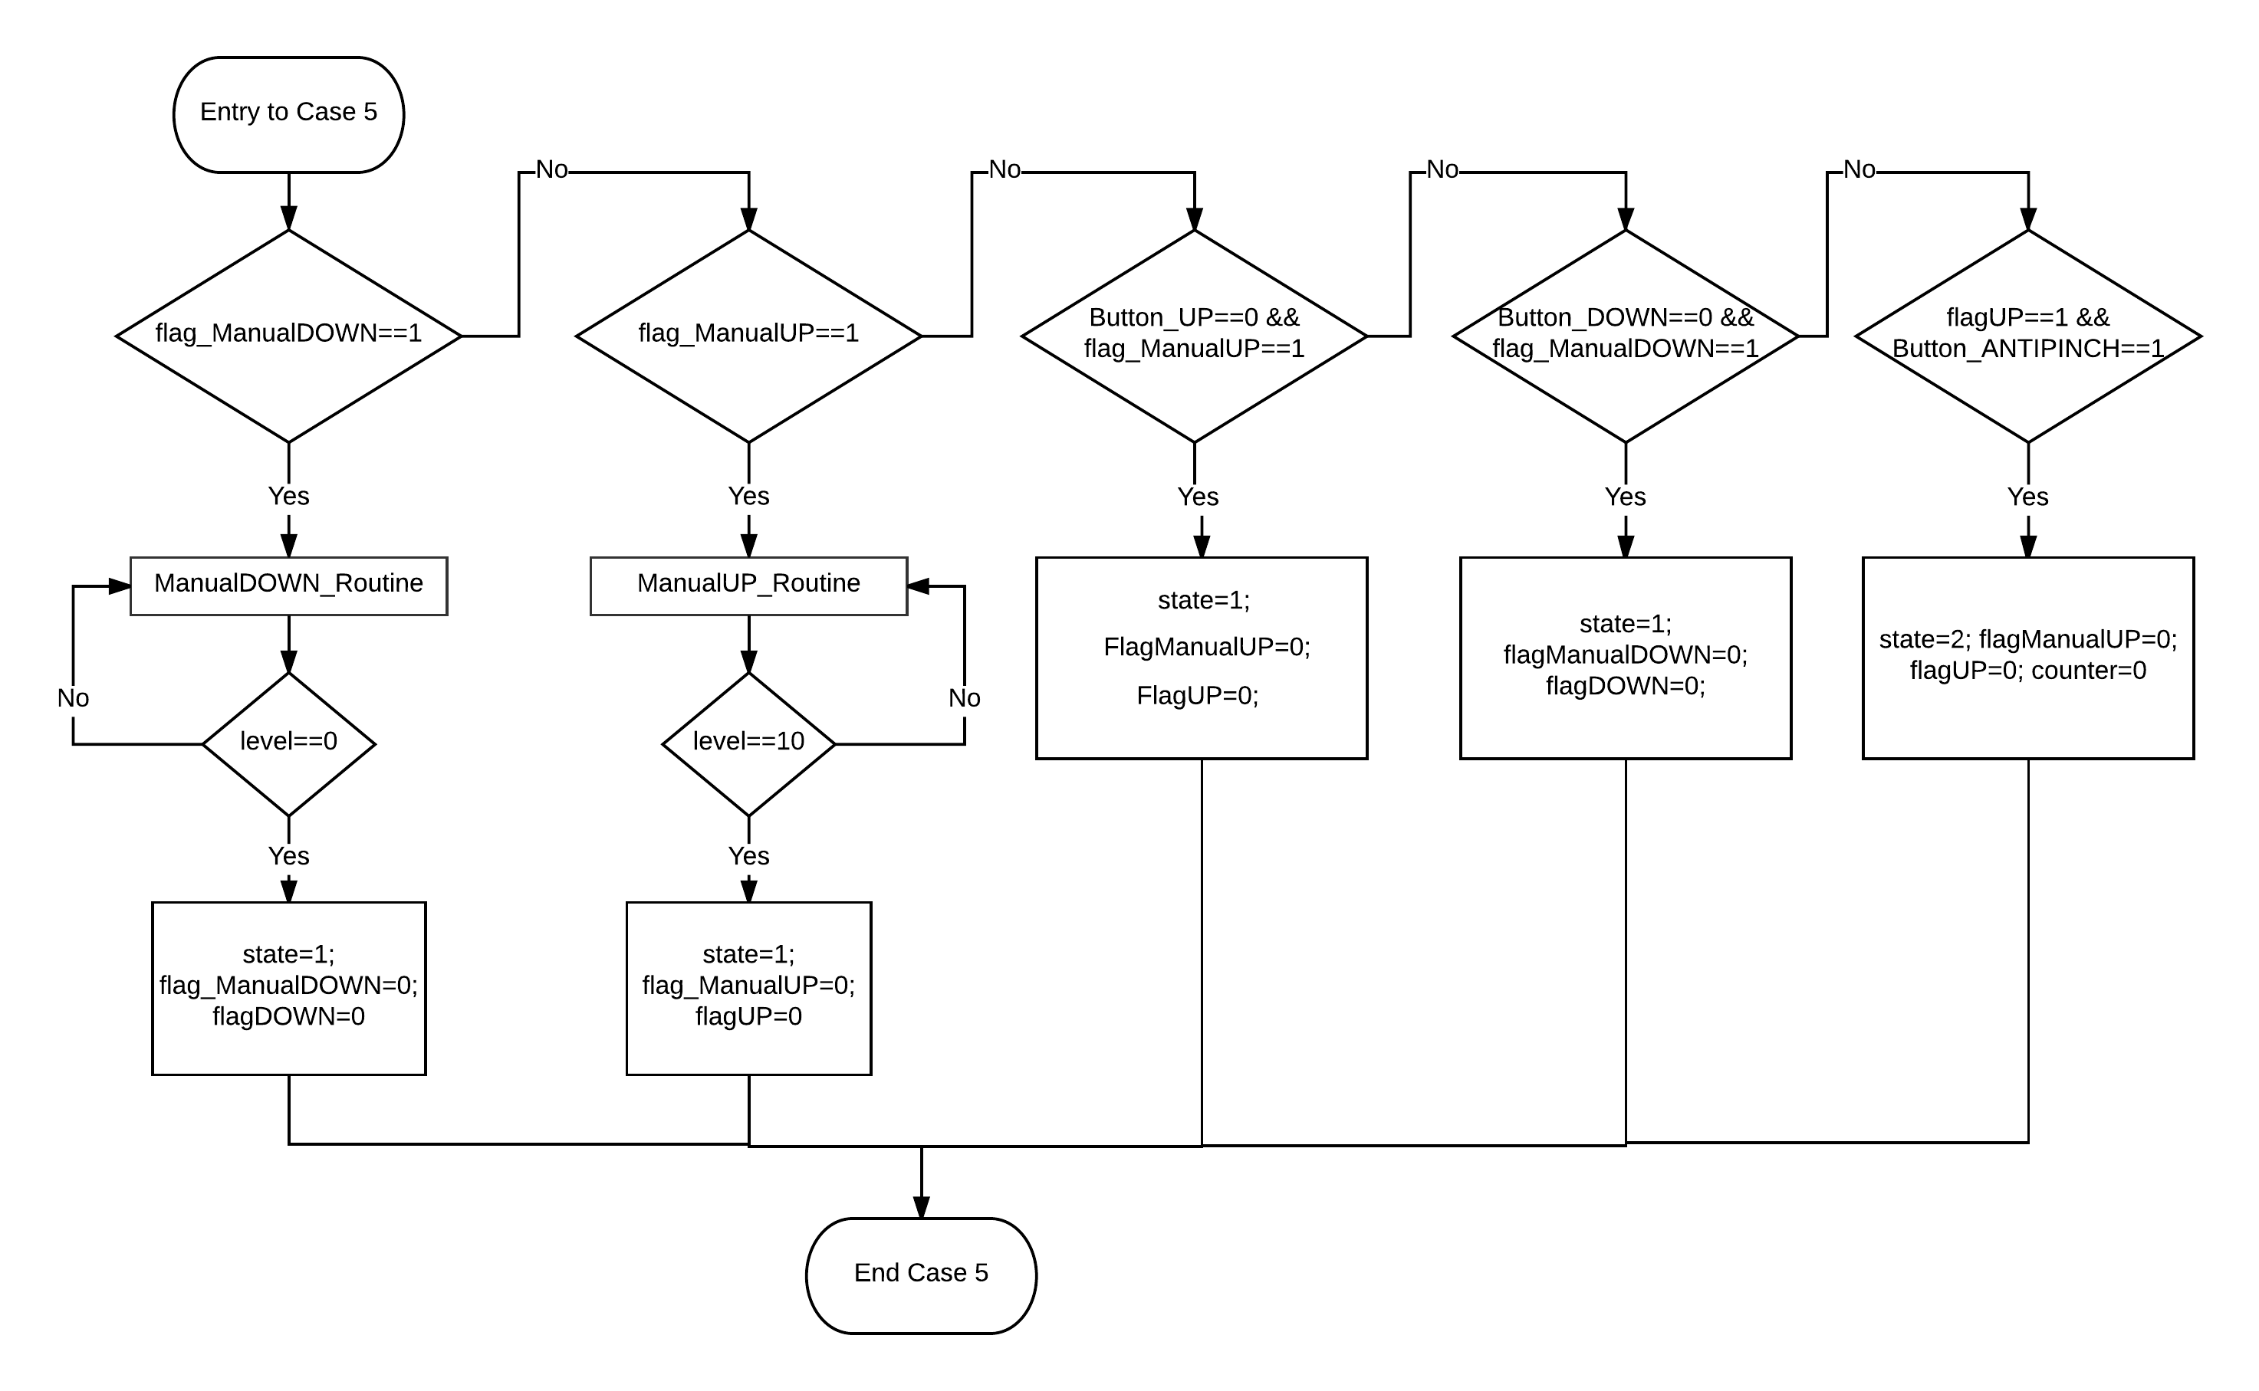
Image 10. “State 5: Manual” dynamic behavior.

DSD_28 – case 6, equivalent to “State 6: Antipinch”

Description | If Anti-pinch button is detected, the window movement shall stop, then it shall move down until totally opened.
Parameter 1  <input| output| inout> | Parameter “state” is a static unsigned char type of variable
Return Value | This function has no return value, because it uses the parameter “state” only to evaluate it.
Precondition | State=Default;  State=2;  State=6;
Post condition | Depending on the transitions (arrows of the Finite State Machine diagram) pre-conditions, the possibilities of the State post-condition are as follows:  State=7;  State=6;
Error Conditions | The error conditions were analyzed and a “default” state was included to solve it

Table 8. case 6, equivalent to “State 6: Antipinch”

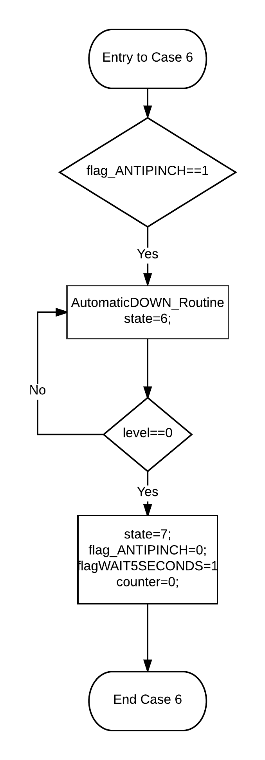
Image 11. “State 6: Antipinch” dynamic behavior.

DSD_29 – case7, equivalent to “State 7: Wait 5 seconds”

Description | The program shall wait for 5 seconds, and then change to the first state.
Parameter 1  <input| output| inout> | Parameter “state” is a static unsigned char type of variable
Return Value | This function has no return value, because it uses the parameter “state” only to evaluate it.
Precondition | State=Default;  State=6;  State=7;
Post condition | Depending on the transitions (arrows of the Finite State Machine diagram) pre-conditions, the possibilities of the State post-condition are as follows:  State=1;  State=7;
Error Conditions | The error conditions were analyzed and a “default” state was included to solve it

Table 9. case 7, equivalent to “State 7: Wait 5 seconds”

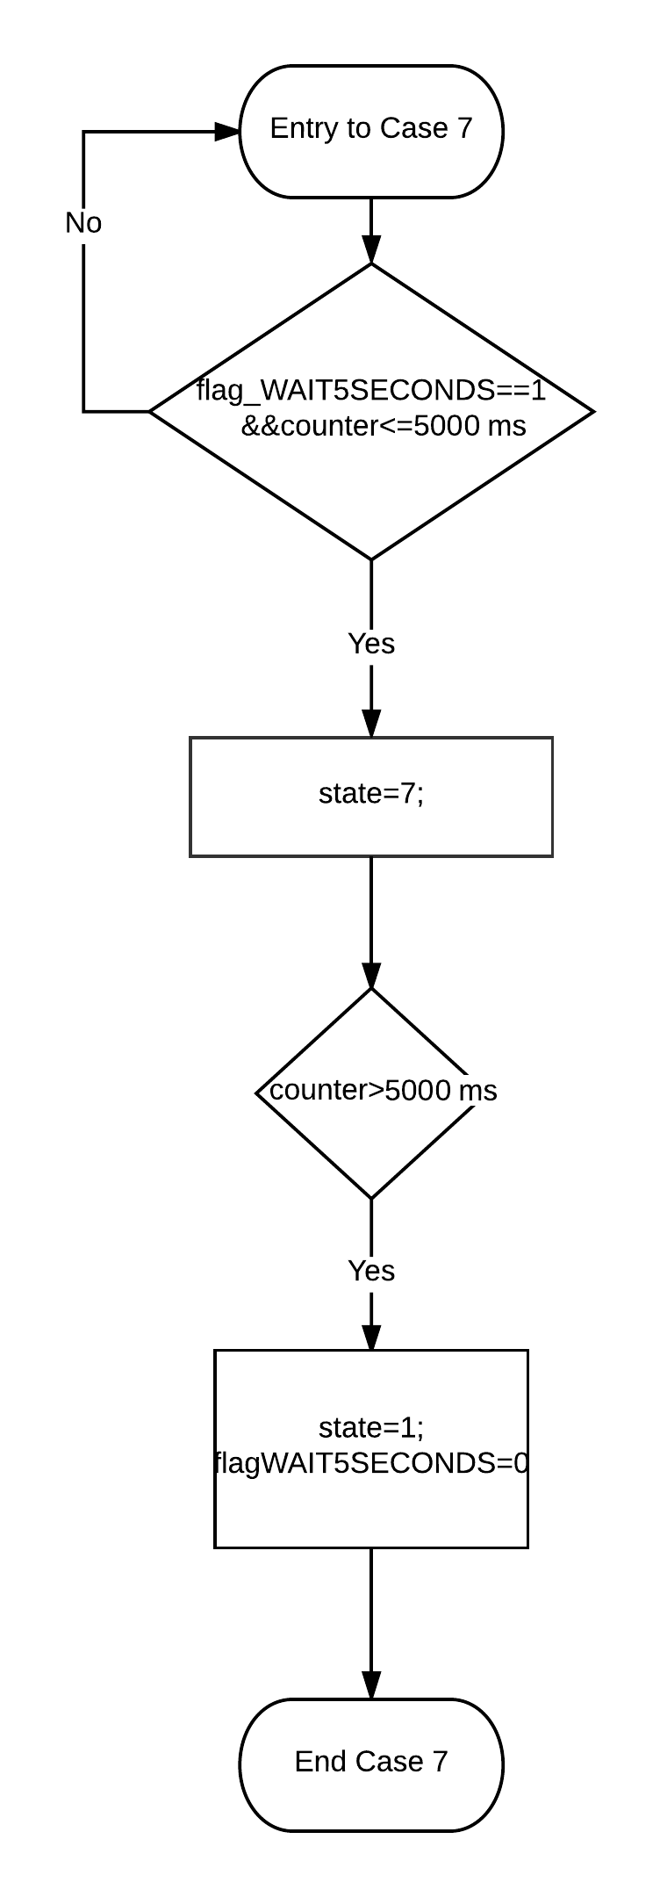
Image 12. “State 7: Wait 5 seconds” dynamic behavior.

